**Database Migration using AWS Database Migration Service**

* In the previous session we have create a vm and installed the mysql db
* We have the following users in mysql database

select user from mysql.user;

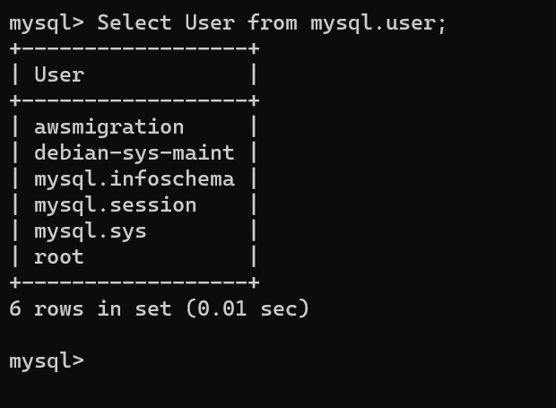  
* To do the the migration we need some database to be present with tables and records in mysql  
* Lets configure the employees database   
* Steps:

git clone https://github.com/datacharmer/test_db.git

cd test_db

sudo mysql -t < employees.sql

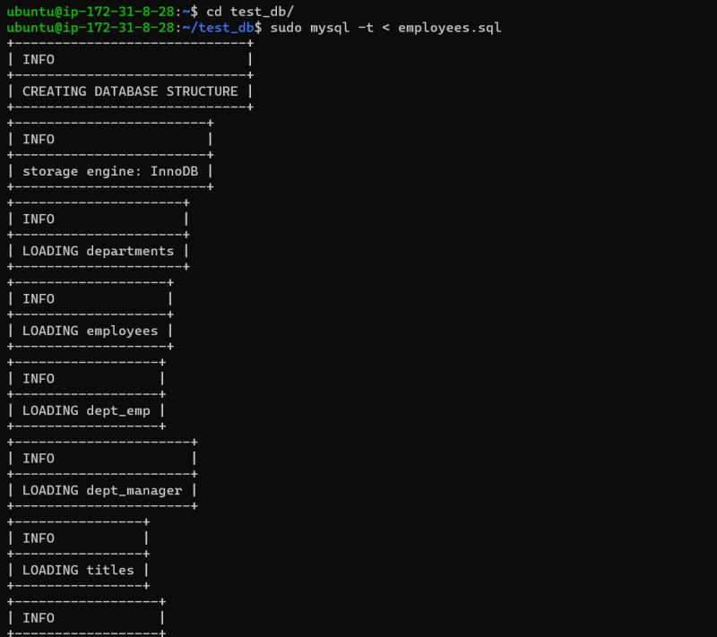  
* Now lets use the following commands

create user 'migration'@'%' Identified by 'MotherIndia@123';

GRANT ALL PRIVILEGES ON employees.* TO 'migration'@'%';

* Now lets test the connectivity from other machine
* To fix the connectivity change the bind address from 127.0.0.1 to 0.0.0.0 /etc/mysql/mysql.conf.d/mysqld.cnf  
  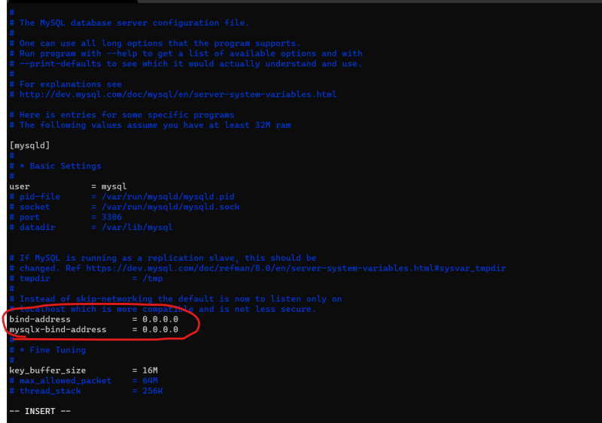
* Restart the mysql service

sudo systemctl daemon-reload

sudo service mysql restart

* Now test the connection from mysql command line or mysql workbench  
  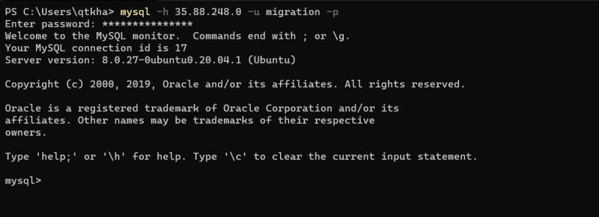

**Migration Approaches** Our aim is to migrate the database from on-premises to AWS RDS  
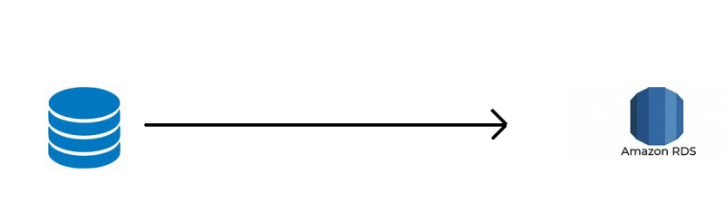

* Data in the database will be constantly updated by applications, so database is constantly changing.
* One approach for migration is to take the downtime (Offline Approach)
* Export the data from database into some format
* Create an RDS Instance and import the exported data
* Not possible if the database size is huge
* Second approach is online migration:
* Here we migrate the data using DMS to RDS in incremental fashion
* Then we will validate the data and run some comparision tests
* when everything is fine, we announce a cut over date and migrate